Project Report: Sudoku Checker and Solver
1.Cover Page
PROJECT REPORT: Sudoku checker and solver
DEVELOPER: Pradicshaa S
DATE OF SUBMISSION: September 29,2026
REPOSITORY LINK: https://github.com/pradicshaa26bhi10125-coder/Sudoku-Puzzle-Solver-Using-Python.git
2.Introduction
This project is a Python-based command-line script designed to structurally validate and automatically solve 9x9 Sudoku puzzles.

3. Problem Statement
The software must programmatically evaluate user-provided Sudoku grids to determine their validity and solve them if a mathematical solution exists.

4. Functional Requirements

- Accept 81 distinct integer inputs (9 rows of 9 columns) from the user, using 0 to represent empty cells.

- Validate the initial grid to ensure no duplicate numbers exist in any given row, column, or 3x3 sub-grid.

- Calculate the missing numbers to complete the puzzle.

- Display both the initial and the final solved matrix in the console.

5. Non-functional Requirements

- Provide a responsive command-line interface.

- Ensure robust state handling so the system accurately communicates if a puzzle is inherently invalid or mathematically unsolvable rather than crashing.

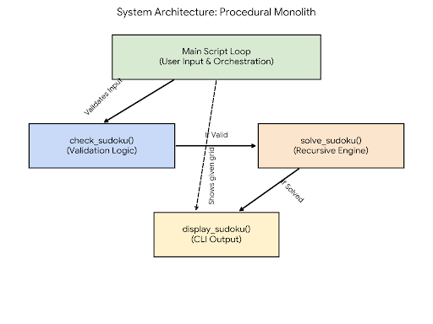
6. System Architecture

7. Design Diagrams
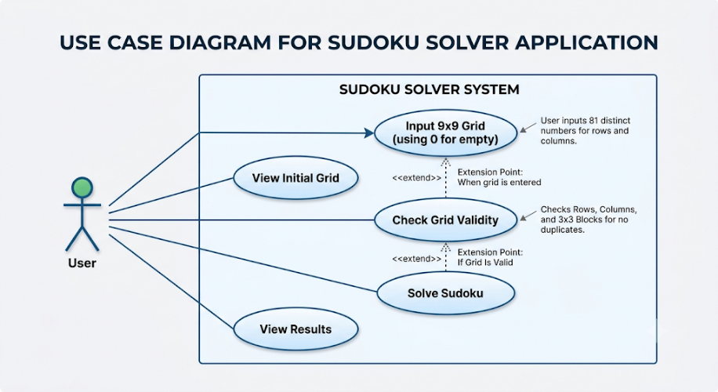
- Use Case Diagram:
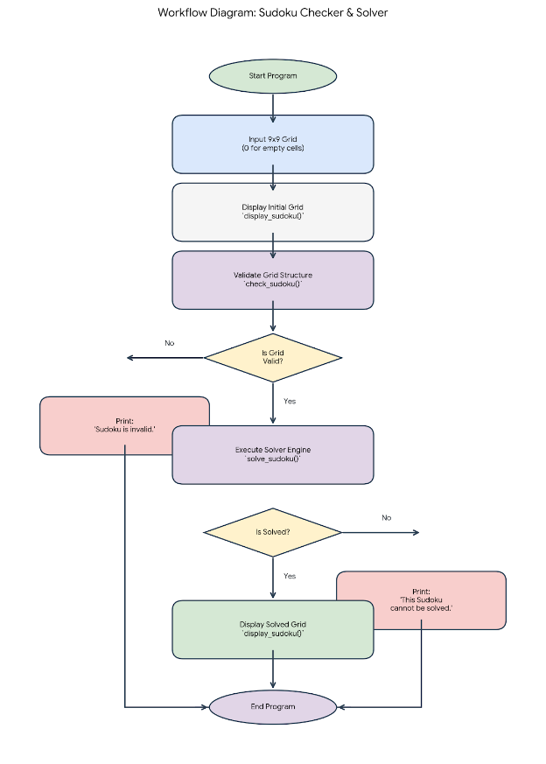
- Workflow Diagram:

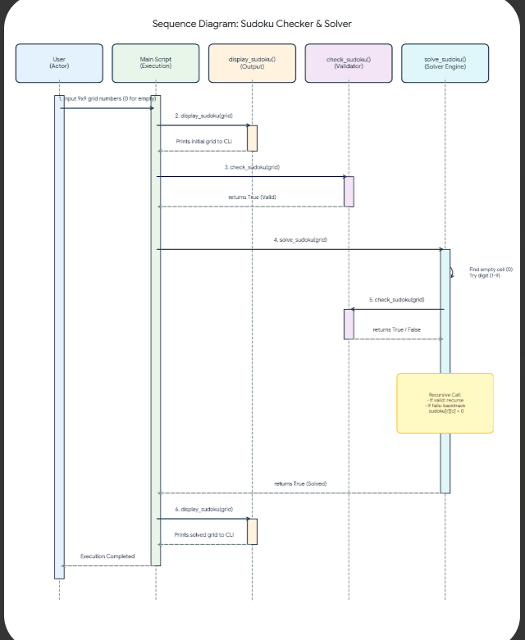
- Sequence Diagram:
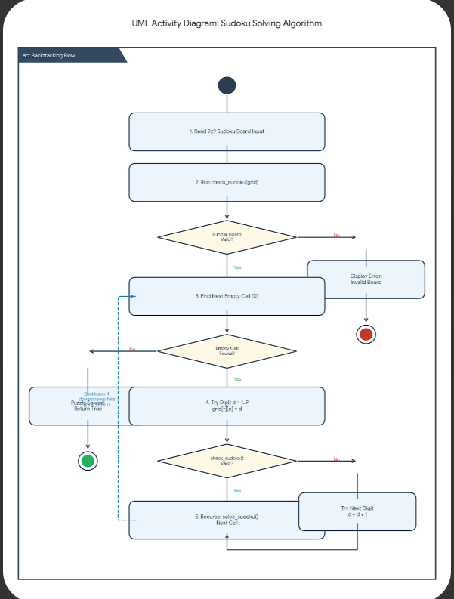
- Class/Component Diagram:

- ER Diagram:
Not applicable, as no external data storage is utilized.

8. Design Decisions & Rationale

- Data Structure: Standard 2D Python lists (arrays) were chosen to hold the grid data to ensure lightweight memory usage and straightforward iteration.

- Algorithm Choice: Recursive backtracking was selected for the solver. This systematically explores numerical combinations and easily reverts the state when it encounters a dead end.

9. Implementation Details

- The logic relies heavily on nested for loops.

- Validation (check_sudoku) isolates rows, columns, and 3x3 sub-grids, appending encountered numbers to a temporary list and returning False if a duplicate is found.

- The solver (solve_sudoku) identifies spaces holding 0, tests digits 1 through 9, recursively calls itself, and resets the space to 0 if the test path fails.

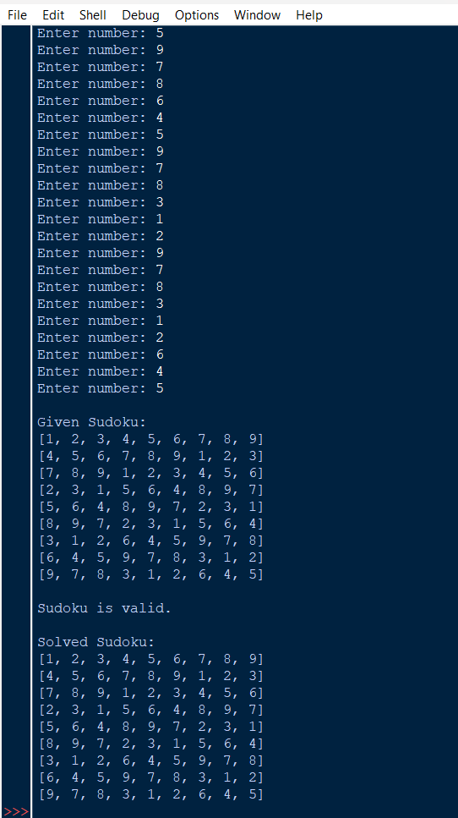
10. Screenshots / Results

11. Testing Approach
The system logic requires testing against multiple states: providing a valid but incomplete grid, providing a structurally invalid grid (e.g., two 5s in the same row), and providing a mathematically unsolvable layout to ensure check_sudoku and solve_sudoku return the correct boolean triggers.

12. Challenges Faced
Developing the matrix traversal limits for the 3x3 sub-grid validation (using steps of 3 in the range() function) and ensuring the temporary variables reset correctly (sudoku[row][column] = 0) during algorithmic backtracking.

13. Learnings & Key Takeaways
The implementation successfully demonstrates core computer science concepts, specifically depth-first search mechanics (backtracking) and multi-dimensional array indexing within Python.

14. Future Enhancements
The application requires 81 individual inputs from the user to populate the board. A future iteration should include parsing from a CSV or .txt file, or an image-recognition pipeline, to bypass this highly tedious manual data entry step.

15. References
All code structure, logic, and implementations analyzed in this report are sourced exclusively from the file pradicshaa 26bhi10125.py.

